64.10.03
From Ernest Giles
H16497 Leichhardt papers, box 13/6(a), La Trobe Australian Manuscript Collection, State Library of Victoria, Melbourne.

Victoria Crescent
East Collingwood
3rd. October 1864
My Dear Dr Mueller
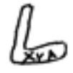
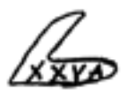

I have read with much interest a portion only of the Printed letter of the Revd. Mr Clarke to the Sydney Morning Herald bearing upon the subject of Marked Trees supposed to have been left by Leichardt and discovered by Mr Heley in the Maranoa Country and by Mr Gregory on the Cooper — A lengthened argument might be entered into on this subject but that is not my intention now I shall merely give my impression & opinion on the marked Trees mentioned by Mr Clarke and my knowledge & experience with regard to other marked Trees that have come under my notice & manipulation & you may agree with me that by an analogy of argument of the facts I have drawn from Trees I have operated upon that I may not be far wrong in my opinion as regards those found by Mr Heley & mentioned by the Revd Mr Clarke — In the first place Mr Heley finds a Camp which He supposes to have been Leichardts and at this Camp a Tree marked it appears to me that this (supposing it to be the full information originally marked on this tree) can have but one of two meanings viz it is either the number of the Camp or the date of it — In the first supposition the numerals may stand for 15 & the letter A for arrival from the Settlements — or it may represent a date the numerals still signifying 15 & the A — for April or August the year being left untold — My opinion is that the Tree was one of Leichardts marked trees & the figures & letters intended to signify the date, but that some other figures & letters may have been hidden under the new Growth of Bark with regard to the 2nd. (or Westward) marked tree found by Mr Heley & marked apparently the same as the other I think it was intended to convey the date &c as I explained before only this time signifying the 25th. of April or August having originally had more numerals & letters marked on it (as) & that a new growth has overgrown the letters &c perhaps hiding the year indicated altogether — The Pith of my argument is this that the Bark or even young Wood of the marked trees found by Mr Heley may have grown over some of the original letters marked on either one or both of the Trees in question as from my own experience I have found it to do — & as I shall show you presently — with regard to the last found by Mr Gregory on the Cooper tho' differing from the others found by Mr Heley in having no other marks attached to it & in general appearance — other original letters may in this instance also have been enveloped by a fresh growth of Bark & young wood — But from Mr. Gregorys opinions & remarks upon it I am inclined to think He has given us every information on the subject that the Tree itself could afford — & that it was Leichardts marked tree & the last known trace we have of him.
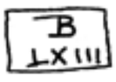
I shall now proceed to show my reasons for forming the opinions I have above stated with regard to the Trees in question — In July 1862 I saw Burkes marked Tree at his first Depôt on Coopers Creek marked thus at the time of my visit the mark was about 18 months old — & the New Bark was rapidly approaching the B as per — No 1 sketch enclosed — In Septr. 1862 on camping on the Ana Branch of the Darling in company with Mr Haverfield I saw an indistinctly marked Tree see sketch No 2 not being able to get any information for it as it then appeared I chopped a portion of the Bark away from the mark & found a legible & distinct mark on the Tree (see also sketch No 2) of a Surveyors marked tree the Camp of the Gentleman who Surveyed the Ana Branch — Also in company with Mr Dunbar of Menindie we found a Tree on the Bend below Menindie Creek with a strange & unintelligible Brand upon it which we could not decipher — but after about an hour's work with a Tomahawk we found that a thick envelope of Bark & young wood had overgrown an old mark on the Tree & eventually we discovered that it was Captain Sturts Marked Tree (see sketch No 3) giving us full information in reward for our trouble — the young wood had completely grown into the notches of the original letters & it was not without considerable nicety of handling that we accomplished our task without injuring the letters beneath — Thus I argue from my own experience that it is highly probable that more information is often hidden under the Bark of Marked trees (after a lapse of time) than appears merely upon the surface — The L found by Mr Gregory certainly appears more elaborately & evenly cut than the others found by Mr Heley & their crooked & warped appearance supports me in the opinions I have expressed — I am also of opinion that a party in search of the remains of Leichardt need not now go any further to the Eastward that the spot where Mr Gregory found the Tree marked L on the Cooper.
I am
Dear Sir
Yours very truly
W. E. P. Giles

No 1

Burkes marked tree at 1st. Depôt on Coopers Creek
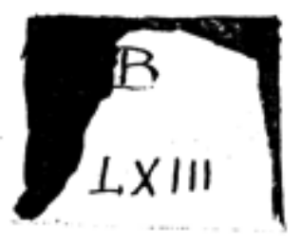

No 2

Marked tree found on Ana Branch of the Darling
Found thus
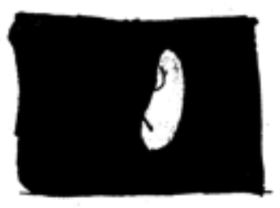

Chopped out & left thus

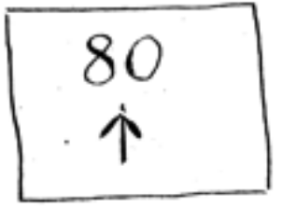

No 3

Marked tree below the Menindie Creek found thus
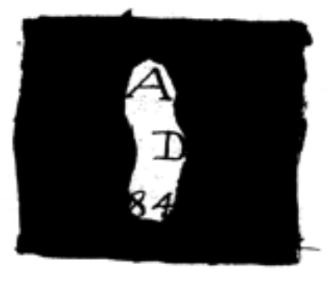

Chopped out & left thus
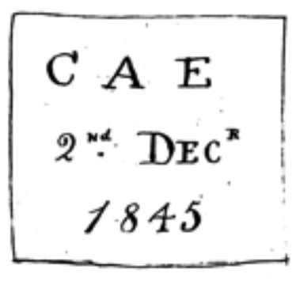
Central Australian Expedition of Captn Sturt

W. B. Clarke, Sydney morning herald, 24 August or 10 September 1858 (the latter being a summary of the earlier article).
64-10-03_image01.jpg.
64-10-03_image02.jpg.
64-10-03_image03.jpg.
64-10-03_image04.jpg.
64-10-03_image05.jpg.
This sketch, and the following sketches referred to, were enclosures and are placed at the end of the letter.
firther deleted before information.
A large letter 'L' in script, not block lettering.
As above.
See also W. Conn to M, 5 September 1864, in which Conn suggests that Giles be sent to investigate graves Conn had discovered over two years before (Giles being a member of his party at the time), said by local Aborigines to be of white men who had been killed by Aborigines.
64-10-03_image06.jpg.
64-10-03_image07.jpg.
found deleted, left interlined.
64-10-03_image08.jpg.
64-10-03_image09.jpg.
64-10-03_image10.jpg.

